Friday, Mar. 23th & Saturday, 24th, 2018

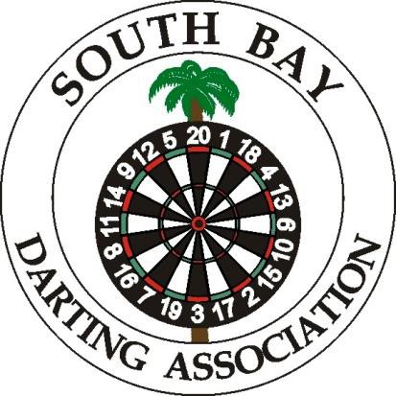
TOURNAMENT LOCATION:
ENCANTO VFW 1512
6873 FEDERAL BLVD, LEMON GROVE, 91945
(619)583-6873
TOURNAMENT DIRECTOR:
Paul Schauer (619) 469-2663

STEEL TIP TOURNAMENT EVENTS ENTRY FEES
Friday’s Event
7:30 pm Blind Draw Doubles $10.00/person Saturday Events
11:00 am 501 Open Doubles $30.00/team 12:30 pm 501 Ladies Singles (straight on) * $20.00/person 1:00 pm 501 Men’s Singles (straight on) * $20.00/person
3.00 pm 501 Mixed Doubles $30.00/team 5:00 pm 501 Ladies Doubles (100% payback) $20.00/team 5:30 pm Open Cricket Doubles $30.00/Team
Ladies are only eligible to shoot in Ladies Doubles or Open Cricket Doubles (One Only)

FRIDAY PAYOUT
1st Place - $200
2nd Place - $100
3rd & 4th Place - $ 50

SATURDAY PAYOUT
MEN’S SINGLES
1st Place – $300 2nd Place – $160
3rd & 4th Place – $80 5t hto 8thPlace– $40

MIXED & OPEN DBLS
1st Place - $240 2nd Place - $120
3rd & 4th Place - $60

LADIES SINGLES
1st Place - $200
2nd Place - $100
3rd & 4th Place - $50

