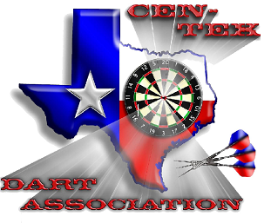
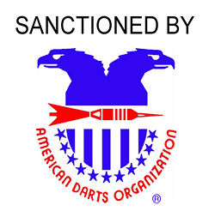
$5,280+ GUARANTEED
AUGUST 17-19, 2012
WACO CONVENTION CENTER
100 WASHINGTON AVE WACO TX
www.centexdarts.com

2^{n d} Annual HOTTER ‘N HELL
Day | Friday | Saturday |  |  |  |  |  | Sunday
Start Time | 8:00 PM | 10:00 AM | 10:30 AM | 12:30 PM | 3:00 PM | 3:30 PM | 7:00 PM | 10:30 AM | 11:00 AM | 12:30 PM | 1:00 PM
Event | Draw # Doubles Chicago | Ladies Doubles 501 | Men Doubles 501 | Mixed Trips 601 | Ladies Singles Cricket | Men’s Singles Cricket | Draw # Doubles Chicago | Ladies Doubles Cricket | Mens Doubles Cricket | Ladies Singles 501 | Mens Singles 501
Entry Fee | $15/PP # | $15/PP | $15/PP | $15/PP | $15/PP* | $15/PP* | $15/PP # | $15/PP | $15/PP | $15/PP* | $15/PP *
1st | $300/1st | $120 | $240 | $240 | $140 | $250 | $300/1st | $120 | $240 | $140 | $250
2nd | $140/2nd | $60 | $100 | $120 | $80 | $170 | $140/2nd | $60 | $100 | $80 | $170
Top 4 | $80/3rd | $40 | $50 | $60 | $30 | $60 | $80/3rd | $40 | $50 | $30 | $60
Top 8 | $60/4th |  | $30 |  |  | $30 | $60/4th |  | $30 |  | $30
 | $30/5-6th |  |  |  |  |  | $30/5-6th
Total | $640 | $260 | $560 | $480 | $280 | $660 | $640 | $260 | $560 | $280 | $660
* Includes ADO Surcharge of $2.00 Tournament Director: Troy McMahan (254) 744-5413 troymac72@msn.com # Draw Doubles are Double Elimination ADO Representative: Jeremy Mathis (254) 717-3963 mathisj72@yahoo.com
HOTEL INFO: All prize amounts shown are per team in team events.
America’s Best Value Inn: Ask for Darter Rates  King room $54.99/ Double room $64.99  115 I-35 Waco Tx 76701 (254)754-1266  1/2 mi. from Convention Center | Courtyard By Marriott: Ask for Darter Rates $99/NIGHT  101 Washington Ave Waco Tx 76701 (254) 752-8686  Across Street from Convention Center(Walking Distance)

