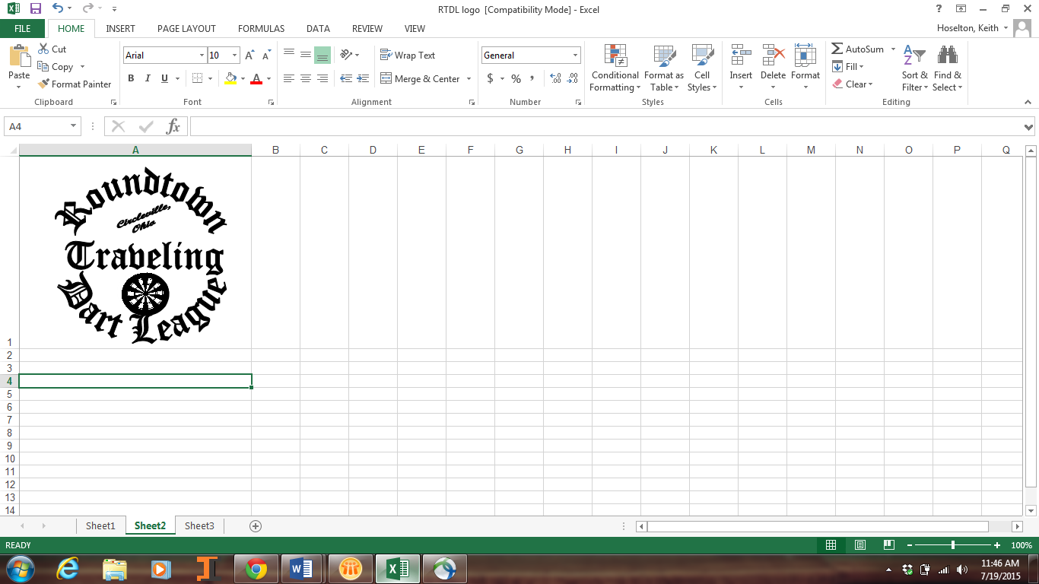



Buckeye Open 35

$15,000+  
December 1ST & 2nd 2017

**NEW LOCATION!**

Hosted by The R.T.D.L  
Home of the Quad City Challenge

**Free breakfast bar for all registered room guests and Happy Hour that we can’t print.**

|  |  |  |  |  |  |  |  |  |  |  |
| --- | --- | --- | --- | --- | --- | --- | --- | --- | --- | --- |
| Event | *Men’s  Singles  Cricket | *Ladies’  Singles  Cricket | Blind  Draw  501 | Men’s  Doubles  501 | Ladies’  Doubles  501 | Ladies’  Doubles  Cricket | Men’s  Doubles  Cricket | *Ladies’  Singles  501 ** | *Men’s  Singles  501 *** | Mixed  Triples  601 |
| Time | 6:30 P.M. | 7:00 P.M. | 9:00 P.M. | 10:00 A.M. | 11:00 A.M. | 1:00 P.M. | 1:30 P.M. | 4:00 P.M. | 4:30 P.M. | 8:00 P.M. |
| Entry Fee | *$20 | *$20 | $15 | $30 | $30 | $30 | $30 | *$20 | *$20 | $45 |
| 1st | $600 | $300 | $450 | $550 | $300 | $300 | $550 | $300 | $600 | $510 |
| 2nd | $300 | $150 | $230 | $280 | $150 | $150 | $280 | $150 | $300 | $270 |
| Top 4 | $150 | $75 | $120 | $140 | $80 | $80 | $140 | $75 | $150 | $150 |
| Top 8 | $75 | $40 | $80 | $70 | $44 | $44 | $70 | $40 | $75 | $90 |
| Top 16 | $40 | $20 | $60 | $44 |  |  | $44 | $20 | $40 | $45 |
| Top 32 | $20 |  | $40 |  |  |  |  |  | $20 |  |
|  | $2140 | $920 | $2360 | $1742 | $786 | $786 | $1742 | $920 | $2140 | $1800 |

Tournament Director: Joey Hoselton khoselto@columbus.rr.com  buckeyeopen@gmail.com Join Buckeye Open on Facebook for updates!

Live Streaming

Full service bar in the Dart Hall. Absolutely NO carry in ALCOHOL or MUGS permitted in the Dart Hall.

Located at the NEWLY RENOVATED   
Embassy Suites Dublin  
5100 Upper Metro Place   
Dublin, Ohio 43017  
1-614-790-9000

Registration closes at the above times.

*Singles Event Registration Amounts Above Do Include ADO Surcharge

Dart Supplies By

[dartrunners@columbus.rr.com](mailto:dartrunners@columbus.rr.com)

Rev.11/10/17

 

Special Darter Rates: $85/night. Q School #3 Has been added Friday afternoon prior

Book by November 9, 2017 to the start of the Buckeye Open. See flyer attached   
 Limited rooms available, book early. Just ask for “Darters Rate” to the Buckeye Open Facebook Page.

On line room registration, available on the Buckeye Open Facebook page

Where every room is a suite