Fri. & Sat. Jan 29th & 30th, 2010

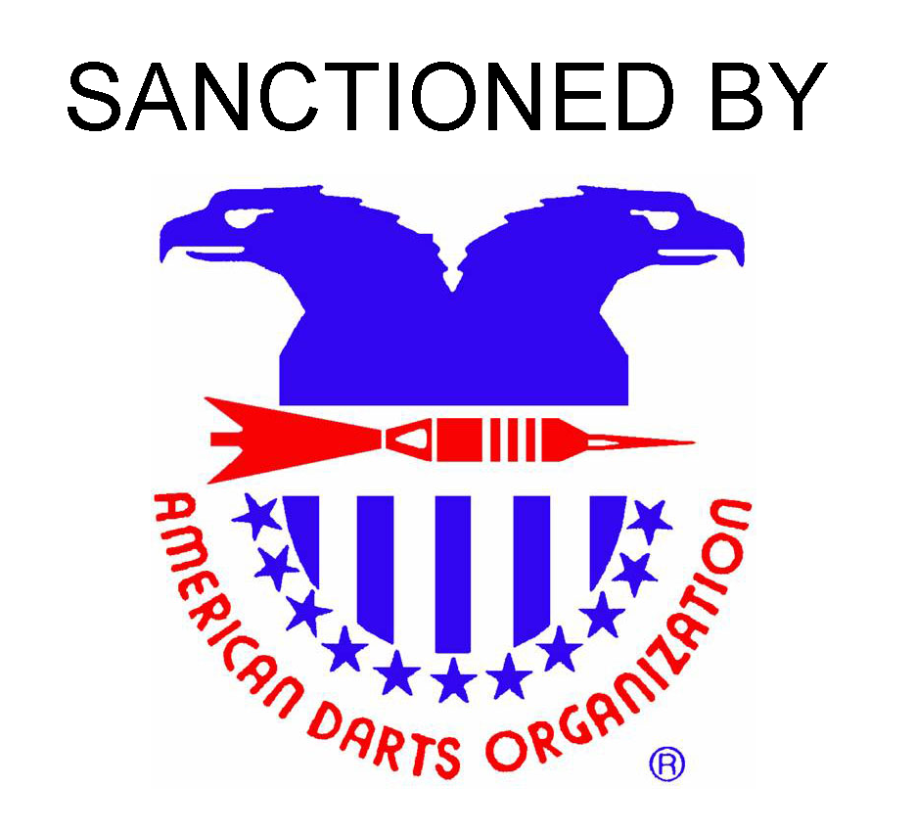
Ramada Hotel
4900 Sinclair Rd (I-71 at Morse Rd)
Columbus, Ohio
(Ask for special darters rates)
614-846-0300

HAPPY HOUR
From 3-5 pm on Friday
 |  | Friday |  |  |  |  |  | Saturday
 | Event |  |  |  | Blind
 | Event | Ain’t Got No Job | Men’s | Women’s | Draw |  |  | Bloody | Men’s | Women’s | Men’s | Women’s |  | Men’s | Women’s | Mixed
 | Event | Open | Singles | Singles | ’501’ |  |  | Mary | Doubles | Doubles | Doubles | Doubles |  | Singles | Singles | Trip
 | Event | Singles | ‘501’ | ‘501’ | Cricket |  |  | Blind | ‘501’ | ‘501’ | Cricket | Cricket |  | Cricket | Cricket | 701
 | Event |  |  |  | Choice |  |  | Draw
 | Time | 5:00 | 6:30 | 7:00 | 9:00 |  |  | 9:30 | 11:00 | 12:00 | 1:30 | 2:00 |  | 4:00 | 4:30 | 8:00
 | Time | PM | PM | PM | PM |  |  | AM | PM | PM | PM | PM |  | PM | PM | PM
 | Fee | $5/ | $16 | $16 | $10 |  |  | $5/ | $28/ | $28/ | $28 | $28 |  | $16 | $16 | $42/
 | Fee | Person | Person | Person | Person |  |  | Person | Team | Team | Team | Team |  | Person | Person | Team
 | 1st | 100% payout | $250 | $200 | $280.00 |  |  | 100% payout | $250 | $170 | $250 | $170 |  | $250 | $200 | $300
 | 2nd | 100% payout | $130 | $100 | $130 |  |  | 100% payout | $130 | $90 | $130 | $90 |  | $130 | $100 | $150
 | 3rd/4th | 100% payout | $90 | $60 | $70 |  |  | 100% payout | $90 | $60 | $90 | $60 |  | $90 | $60 | $80
 | 5th/8th | 100% payout | $60 | $35 | $50 |  |  | 100% payout | $60 | $40 | $60 | $40 |  | $60 | $35 | $60
 | Total | 100% payout | $800 | $560 | $750 |  |  | 100% payout | $800 | $540 | $800 | $540 |  | $800 | $560 | $850
Registration Closes At  Time Shown |  |  |  |  |  | MINI BLIND DRAWS  start 3:15 Friday  BAR + HALL OPEN 3pm FRIDAY |  |  |  |  |  |  | COLUMBUS DARTERS ASSOCIATION  www.cols-darters-assn.com  col_darters_assn@yahoo.com

