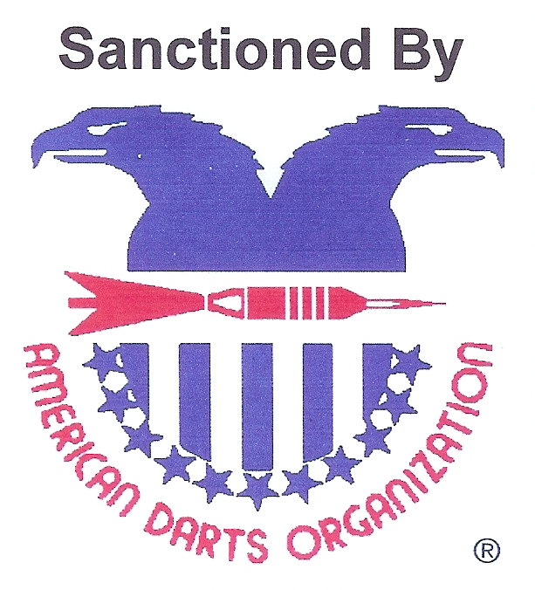
$5000
2010 Chili Classic
April 16th, 17th, and 18th

American Legion Post 49
11007 Central Ave. N.E. Albuquerque, N. M. 87123
⁵⁰⁵⁻²⁹⁶⁻⁴²²⁴
Rooms Available At Sandia Courtyard Hotel

10300 Hotel Ave N.E. Albuquerque N. M. N.E. 87123
505-296-4852
Base Rate $55 Upgrades with refrigerator $65 ask for Darters Rates
Both rooms come with breakfast for up to 4 per room and on the hour shuttle to event

ADO Regional 501 Shoot Out
Friday April 16th Noon Sharp

All entries Close 15 minutes prior to event

DAY | FRIDAY | SATURDAY |  |  |  |  |  | Sunday
TIME | 8:00 PM | 11:00 AM | 11:30 AM | 2:00 PM | 2:30 PM | 5:00 PM | 8:00 PM | 11:00 AM | 2:00 PM | 2:30 PM
 | BLIND | MEN'S | LADIE'S | MEN'S | LADIE'S | Open | BLIND | Mixed | MEN'S | LADIE'S
EVENT | DRAW | DOUBLES | DOUBLES | SINGLES | SINGLES | Doubles | DRAW | Trips | SINGLES | SINGLES
 | 501 | CRICKET | CRICKET | CRICKET | CRICKET | 501 | PENGUIN | 701 | 501 | 501
 | $10 | $24 | $24 | $20* | $20* | $24 | $10 | $45 | $20* | $20*
FEE | PERSON | TEAM | TEAM | PERSON | PERSON | TEAM | PERSON | TEAM | PERSON | PERSON
1ST | $240 | $230 | $200 | $200 | $180 | $200 | $240 | $300 | $200 | $180
2ND | $120 | $110 | $100 | $100 | $90 | $100 | $120 | $150 | $100 | $90
TOP 4 | $60 | $50 | $50 | $50 | $45 | $50 | $60 | $75 | $50 | $45
TOP 8 | $30 | $30 | N/A | $25 | N/A | $30 | $30 | N/A | $25 | N/A
TOTAL | $600 | $560 | $400 | $500 | $360 | $520 | $600 | $600 | $500 | $360
*Includes $2 ADO Fee
Penguin Rules Best 2 out of 3. 501 , Cricket, 301 if needed
Hotmail: Trusted email with powerful SPAM protection. Sign up now.

