
Midwest Support Services, Inc. presents the

MIDWEST SUMMER CLASSIC VI
JULY 10-12, 2009
$6,545 Payout
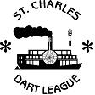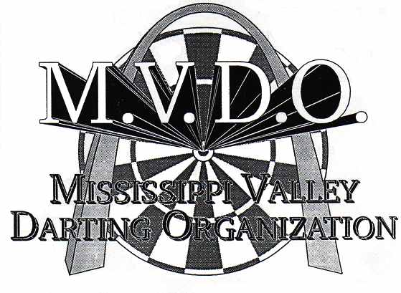
Tournament Location:

St. Charles Moose Lodge #1513
2705 Veterans Memorial Pkwy
St. Charles, MO 63303
Telephone (636) 723-7794
(15 minutes from Lambert Airport)
ADO US Team Regional Qualifier
Fri. July 10
Registration 11 am – Play begins at Noon

Tournament Director:

Sue Hackett - SCDL
1109 Holly Springs Tr.
St. Peters, MO 63376
Telephone: (314) 393-4787
e-mail: suebee6612@charter.net
Tournament Director:

Dave Madison - MVDO
12145 Hillcrest Place
St. Louis, MO 63043
Telephone: (314) 739-0437
e-mail: dave@9count.com

Hotel Info:
Holiday Inn – West Earth City
3400 Rider Trail South
St. Louis, MO 63045
Ph. (800) 972-3145
www.holidayinn.com

Darter Rate
$59.99/nite
Free shuttle to/from hall

DAY: | FRIDAY |  | SATURDAY |  |  |  |  |  | SUNDAY
TIME: | 7:00 pm | 9:00 pm | 11:00 am | 2:00 pm | 2:30 pm | 5:00 pm | 5:30 pm | 8:00 pm | 10:30 am | 12:00 pm | 12:30 pm | 2:00 pm | 2:30 pm
EVENT: | Blind Draw | Blind Draw | Mixed Triples | Ladies Doubles | Men’s Singles | Ladies Singles | Open Doubles | Blind Draw | Mixed Doubles | Men’s Singles | Ladies Singles | Open Doubles | Ladies Doubles
 | 501 | Cricket | Cricket | Cricket | 501 | 501 | Cricket | 501/Cricket | 501 | Cricket | Cricket | 501 | 501
FEE: | $10 | $10 | $30 | $20 | $15* | $15* | $20 | $10 | $20 | $15* | $15* | $20 | $20
1ST | $240 | $200 | $300 | $160 | $200 | $140 | $250 | $240 | $220 | $150 | $110 | $200 | $140
2ND | $120 | $100 | $150 | $80 | $120 | $70 | $130 | $120 | $110 | $75 | $60 | $100 | $70
3RD- 4TH | $60 | $50 | $75 | $40 | $60 | $40 | $80 | $60 | $60 | $50 | $30 | $50 | $40
5TH- 8TH | $30 | $30 | $45 | - | $30 | $20 | $40 | $30 | $30 | $25 | $15 |  | -
9th – 16th | - | - | - | - | $15 | - | - | - | - | - | - | - | -
PAY-OUT: | $600 | $520 | $780 | $320 | $680 | $370 | $700 | $600 | $570 | $425 | $290 | $400 | $290
*Includes $2.00 ADO surcharge

This is a steel tip dart tournament; all matches are single elimination, two of three. Registration will close 15 minutes prior to each event.
Please, no outside beverages are allowed into the dart hall.

