Brought to you by:    http://www.pghdarts.com  and Sponsors:    http://www.thirdway.net  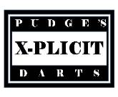  http://www.xplicitdarts.com    http://www.webcamdarts.com | 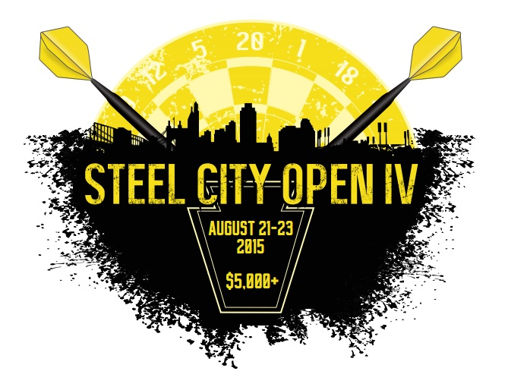  August 21-23 2015 http://steelcity-open.com/  Pittsburgh Darters membership required – Weekend membership available for $5.00 |   http://www.dartguys.com  Sanctioned by:    http://www.adodart.com
  LOCATION/ HOTEL:  Econo Lodge  110 E Byers Ave  New Stanton, PA 15672  (724) 925-6755  “Steel City Open”  $65.99 + Tax / Night | TOURNAMENT DIRECTORS:  Paul Manculich  (412) 901-9353  pudge017@yahoo.com  Bill East  (724) 554-8037  billeast@thirdway.net | Youth Event:  There will be a Sunday 8:30am Youth/Adult tournament. The tournament will be divisionalized. | MVP Rewards:  There will be a singles Male and Female MVP awarded to the individuals that have the best overall weekend. We base this on points earned in all events accept the Early Bird. You do get a single point for each event entered.
All doubles/mixed events are best 2 out of 3. * Singles events are 2 out of 3 until top 4 which is 3 out of 5. ** Open Singles event is 3 out of 5 until top 4 which is 4 out of 7 finals is 5 out of 9
(* $2.00 ADO Sanctioning fee per singles is included in entry fee) (Registration cutoff 15 minutes before each match). Finals Matches will be recorded!!

Day | FRI | Fri | FRI | Sat | Sat | sAT | Sat | Sat | SAT | SAT | SAT | SUN | SUN | SUN
TIME | 5:30 PM | 7:30 PM | 9:00 PM | 10:30 AM | 1:30 PM | 2:00 PM | 4:00 PM | 4:30 PM | 7:00 PM | 7:30 PM | 9:30 PM | 10:00 AM | 1:00 PM | 1:30 PM
EVENT | Early Bird  Pittsburgh  Pick OFF | Open  Singles  301  DI/DO | Blind  Draw  Cricket | Mixed  Triples  601 | Men’s  Doubles  Cricket | Ladies  Doubles  Cricket | Men’s  Singles  501 | Ladies  Singles  501 | Men’s  Doubles  501 | Ladies  Doubles  501 | Blind  Draw  501/Cri/Ch | Mixed  Doubles  501/Cri/Ch | Men’s  Singles  Cricket | Ladies  Singles  Cricket
Fee | $10  Person | $20  Person** | $20  Person | $60  Team | $40  Team | $40  Team | $22  Person* | $22  Person* | $40  Team | $40  Team | $20  Person | $40  Team | $22  Person* | $22  Person*
1ST | 100% Payback | $200 | 85% Payback | $330 | $300 | $150 | $200 | $100 | $300 | $150 | 85% Payback | $250 | $200 | $100
2ND | 100% Payback | $100 | 85% Payback | $210 | $150 | $80 | $100 | $50 | $150 | $80 | 85% Payback | $125 | $100 | $50
3RD / 4TH | 100% Payback | $50 | 85% Payback | $90 | $70 | $40 | $50 | $25 | $60 | $40 | 85% Payback | $50 | $50 | $25
5th / 8th | 100% Payback | $10 | 85% Payback | $30 | $20 |  | $10 |  | $20 |  | 85% Payback | $20 | $10
TOTAL | 100% Payback | $440 | 85% Payback | $840 | $670 | $310 | $440 | $200 | $650 | $310 | 85% Payback | $555 | $440 | $200

