The Central Missouri Dart Association presents the

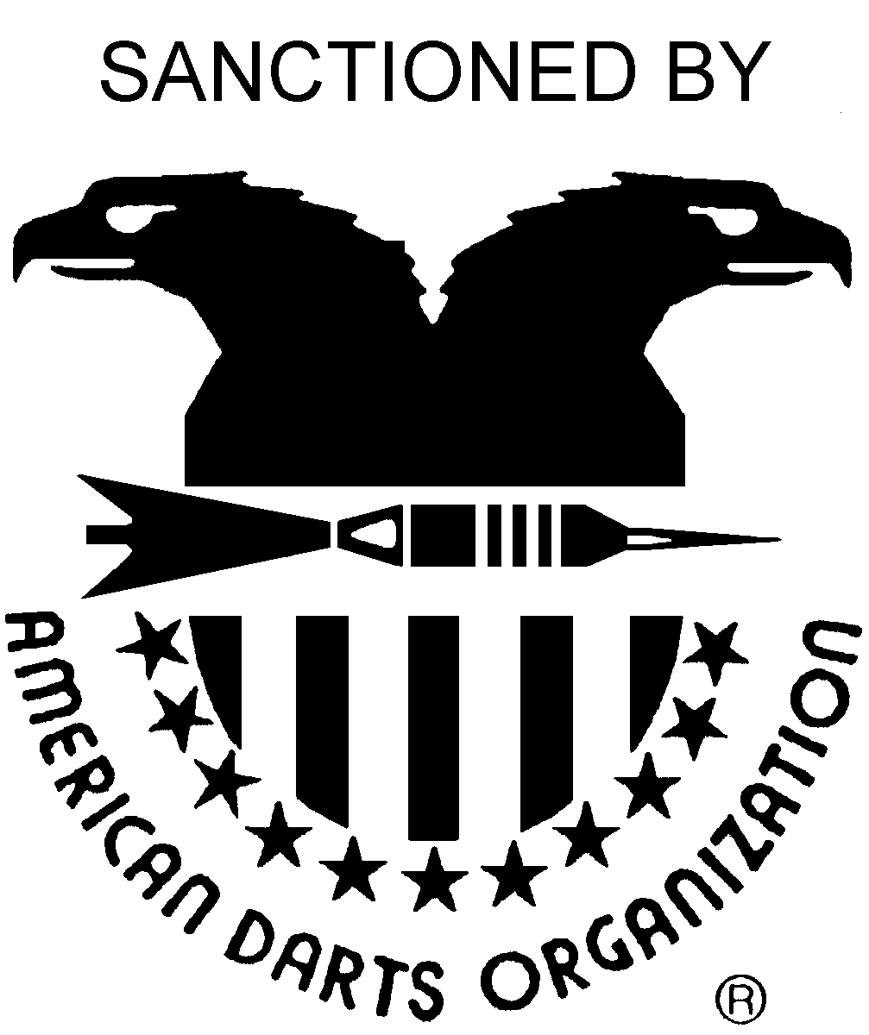
7th ANNUAL MEMORIAL CLASSIC
OCTOBER 29-31st, 2010

$2,300 + Payout
plus Blind Draws

Hotel and Tournament Location:

Truman Hotel and Conference Center
1510 Jefferson Street
Jefferson City, MO 65109
Telephone (573) 635-7171
Ask for Darters Rates

CMDA President:

Diane Bernskoetter
Telephone: (573) 230-9013
Website: www.cmdadarts.org
ADO Cricket Singles Championship Regional Qualifier
Sunday October 31st, 2010
Registration 10 am – Play begins at 11 am

PLEASE SPREAD THE WORD AND HELP US MAKE THIS A GREAT EVENT
 |  |  | Registration Closes 15 minutes prior to posted start time. No Exceptions.
DAY: | FRIDAY |  |  | SATURDAY |  |  |  |  |  |  |  |  |  | SUNDAY
TIME: | 6:30 PM | 7:30 PM | 9:00 PM | 10:00 AM | 12:00 PM | 12:00 PM | 2:00 PM | 2:00 PM | 4:00 PM | 6:00 PM | 6:00 PM | 8:00 PM | 9:30 PM | 12:00 PM | 2:00 PM
EVENT: | Open Singles Pro Shoot | Doubles Blind Draw#% | Doubles Blind Draw# | Mixed Doubles | Mens Doubles | Ladies Doubles | Mens Singles | Ladies Singles | Open Doubles | Mens Singles | Ladies Singles | Doubles Blind Draw#% | Doubles Blind Draw# | Blind Draw# | Blind Draw#
 | 301 DIDO | Cricket | 501 | 501 | Cricket | Cricket | 501 | 501 | 501 | Cricket | Cricket | 501 | Cricket | Chicago | 501
FEE: | $15 | $10 | $10 | $20 | $20 | $20 | $12* | $12* | $20 | $12* | $12* | $10 | $10 | $10 | $10
1ST | $120 | 40% | 40% | $150 | $150 | $100 | $150 | $100 | $150 | $150 | $100 | 40% | 40% | 40% | 40%
2ND | $60 | 20% | 20% | $76 | $76 | $50 | $75 | $50 | $76 | $75 | $50 | 20% | 20% | 20% | 20%
3RD- 4TH | $30 | 10% | 10% | $36 | $36 | $26 | $25 | $25 | $36 | $25 | $25 | 10% | 10% | 10% | 10%
5TH- 8TH | - | - | - | - | - | - | $10 | - | - | $10 | - | - | - | - | -
PAY-OUT | $240 | 80% | 80% | $298 | $298 | $202 | $315 | $200 | $298 | $315 | $200 | 80% | 80% | 80% | 80%
 |  |  | #Denotes 80% Payout for all Blind Draw Events, 20% to CMDA Memorial Fund
 |  |  | % Denotes that if you are still in the Singles event you cannot play in this Blind Draw event
 |  |  | *Denotes $2.00 ADO Singles Fee
This is a steel tip dart tournament; all matches are single elimination, two of three. The CMDA Board may increase the payout if participation is larger than expected.
Please, no outside beverages are allowed into the dart hall.

