

San Diego MEMORIAL V
DART TOURNAMENT
sdmdt.org
$3,500.00 Guaranteed Pay Out
Nov. 4th & 5th, 2011
Silent Auction
Raffles Great Prizes

Williams Barn, Walnut Grove Park
San Marcos, California
ADO Sanctioned Event

Date | Friday 5th | Saturday 6th | Saturday 6th | Saturday 6th | Saturday 6th | Saturday 6th
Start Time | 7:30 PM | 10:00 AM | 12:30 PM | 2:00 PM | 3:00 PM | 3:30 PM
Format | 501 Best 2 of 3 | 501 Best 2 of 3 | Cricket Best 2 of 3 | 501 Best 2 of 3 | 501 Best 2 of 3 | 501 Best 2 of 3
Fees | $15.00 Each | $15.00 Each | $20.00 Each | $30.00 Team | $20.00 Each | $20.00 Each
Event | Blind Draw | Blind Draw | Open Singles | Open Doubles | Men's Singles | Women's Singles
1st Place |  | $220.00 | $300.00 | $320.00 | $300.00 | $150.00
2nd Place | 100% | $120.00 | $160.00 | $200.00 | $160.00 | $90.00
3rd - 4th | Payback | $60.00 | $80.00 | $120.00 | $80.00 | $40.00
5th-8th |  | $40.00 | $40.00 | $40.00 | $40.00 | $20.00
Total |  | $620.00 | $780.00 | $920.00 | $780.00 | $400.00
A
Director: Mike Enright 011-521-686-203-2274 Williams Barn, Walnut Grove Park
Chairman: Charles Bradish (619) 606-4880 1950 Sycamore Drive
San Marcos, CA 92069
www.ci.san-marcos.ca.us

Victor’s Luz Restaurant
Breakfast – American Buffet Lunch – Mexican Fare
9-11:30 am 11:30-5pm
B
D
Lodging: Ramada Limited San Marcos RV Parks: Escondido RV Resort

(760) 471-2800 (760) 740-5000
www.ramada.com www.escondidorv.com
C
E
Hampton Inn San Marcos Ivy Del RV Park & Sales
(760) 736-9249 (760) 745-2131
hamptoninn.hilton.com rvparkfinder.net

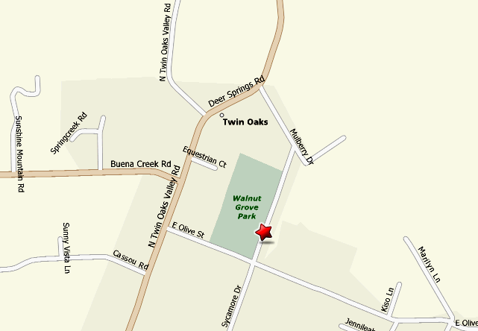

Map of Williams Barn, Walnut Grove Park in San Marcos, CA –Mapquestlink.

